|  |  |  |  |  |  |  |
| --- | --- | --- | --- | --- | --- | --- |
| sector_header | | | | | | |
|  | **NLP4StatRef: Methodological support on advanced methods for accessing, ingesting and linking textual information using semantic analysis and natural language processing** | | | | | |
| partner_flag1  partner_flag2 | Content database and Knowledge database Documentation | | | | | |
|  | | | | | |
|  | | | | | |
| Specific contract N° 000068  Under  Framework Contract N° 2018.0088, Lot 1: Methodological support | | | | | |
|  |  | evaluation_03 |  | evaluation_01 |  |  |
|  | April 2022 | | | | | |

#### NLP4StatRef Ontology ¤ Classes

| Class | Usage note | URI | Reference |
| --- | --- | --- | --- |
| Classification | All types of controlled Category, Types, Topics, and others | estat:Classification | http://nlp4statref/ontology# Classification |
| Category | A class that represents the Categories that EuroStat offers | estat:Category | http://nlp4statref/ontology# Category |
| GlossaryArticleCategory | A class that contains the categories for the Glossary Articles | estat:GlossaryArticleCategory | [http://nlp4statref/ontology#GlossaryArticleCategory](http://nlp4statref/ontology#GlossaryArticleCategory ) |
| StatisticsExplainedCategory | A class that contains the categories for the Statistics Explained Articles | estat:StatisticsExplainedCategory | http://nlp4statref/ontology#StatisticsExplainedCategory |
| Topic | A class that represents the topics, given by the collegues at Quantos | estat:Topic | https://www.w3.org/TR/skos-reference/#Topic |
| Type | A class that contains various types, statistical units, and measurement units among others | estat:Type | http://nlp4statref/ontology#Type |
| ConceptType | A class with the concept types | estat:ConceptType | http://nlp4statref/ontology#ConceptType |
| InfoType | A class with the Information types | estat:InfoType | http://nlp4statref/ontology#InfoType |
| LexicalType | A class with the lexical types | estat:LexicalType | http://nlp4statref/ontology# LexicalType |
| MeasurementType | A class with the measurement unit types | estat:MeasurementType | http://nlp4statref/ontology# MeasurementType |
| StatisticalType | A class with the statistical unit types | estat:StatisticalType | http://nlp4statref/ontology# StatisticalType |
| StatusType | A class with the status types | estat:StatusType | http://nlp4statref/ontology# StatusType |
| Content | All types of described and annotated content. | estat:Content | http://nlp4statref/ontology#Content |
| Article | All the information written and published around the statistical data, to comment on them and explain them. | estat:Article | http://nlp4statref/ontology#Article |
| StatisticsExplainedArticle | A class with the statistics explained articles | estat:StatisticsExplainedArticle | http://nlp4statref/ontology#StatisticsExplainedArticle |
| Glossary Article | A class with the Glossary Articles | estat:GlossaryArticle | http://nlp4statref/ontology#GlossaryArticle |
| BackgroundArticle | A class with the Statistics Explained Articles that are also Background Articles | estat:BackgroundArticle | http://nlp4statref//ontology#BackgroundArticles |
| Statistical Data | Abstract class for statistical content of the datasets | estat:StatisticalData | http://nlp4statref/ontology#StatisticalData |
| GlossaryTerm | All types of controlled vocabularies, dictionaries, and others. | estat:GlossaryTerm | http://nlp4statref/ontology#GlossaryTerm |
| Code | A class that contains the codes that the statistical datasets are related to | estat:Code | http://nlp4statref/ontology#Code |
| CODEDTerm | Glossary is an alphabetical list of terms relating to a specific subject enriched by definitions and related content. | estat:CODEDTerm | http://nlp4statref/ontology#CODEDTerm |
| NamedEntity | A class that contains the named entities existing in EuroStat Content Dataset | estat:NamedEntity | http://nlp4statref/ontology# NamedEntity |
| OECDTerm | A class that represents the OECD data | estat:OECDTerm | http://nlp4statref/ontology#OECDTerm |
| Theme | A class that represents the Themes that EuroStat offers | estat:Theme | http://nlp4statref/ontology#Theme |
| Paragraph | A class that contains the information for the paragraphs of the Statistics Explained Articles | estat:Paragraph | http://nlp4statref/ontology#Paragraph |
| OECDTheme | A class that contains the OECD themes | estat:OECDTheme | http://nlp4statref/ontology#OECDTheme |
| EurostatTheme | A class with the Eurostat themes | estat:EurostatTheme | http://nlp4statref/ontology#EurostatTheme |
| Reference | A class that represents material (resources / articles / web sources) referenced from within an instance of class content (e.g. an article) | estat:Reference | http://nlp4statref/ontology#Reference |
| ExternalLink | A class with the external references / articles / web sources | estat:ExternalLink | http://nlp4statref/ontology#ExternalLink |
| Visualization | A class with the visualization references / articles / web sources | estat:Visualization | http://nlp4statref/ontology#Visualization |
| Legislation | A class with the legislation references / articles / web sources | estat:Legislation | http://nlp4statref/ontology#Legislation |
| Methodology | A class with the methodology references / articles / web sources | estat:Methodology | <http://nlp4statref/ontology#Methodology> |
| Publication | A class with the publication references / articles / web sources | estat:Publication | http://nlp4statref/ontology#Publication |
| DedicatedSection | A class with the dedicated section references | estat:DedicatedSection | http://nlp4statref/ontology#DedicatedSection |
| Database | A class with references to databases | estat:Database | http://nlp4statref/ontology#Database |
| Table | A class with references to tables | estat:Table | http://nlp4statref/ontology#Table |
| OtherArticle | A class with references to other articles | estat:OtherArticle | http://nlp4statref/ontology#OtherArticle |
| Excel | A class with references to excellence resources / articles / web sources | estat:Excel | http://nlp4statref/ontology#Excel |

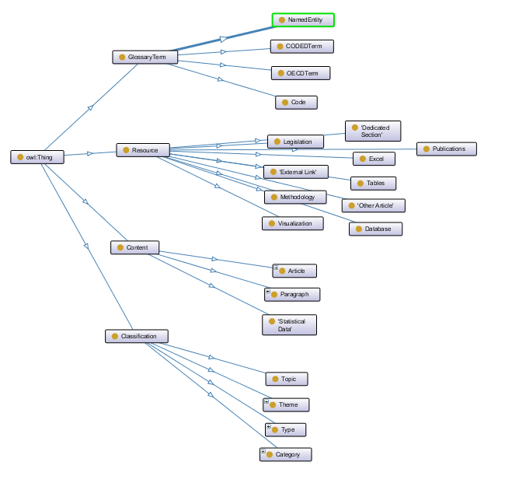

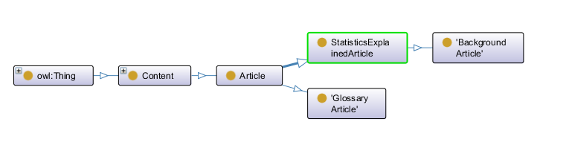

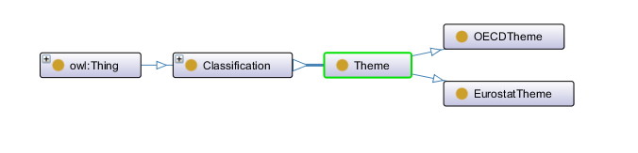

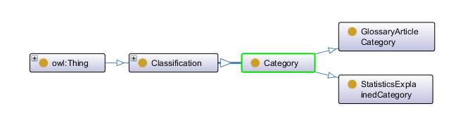

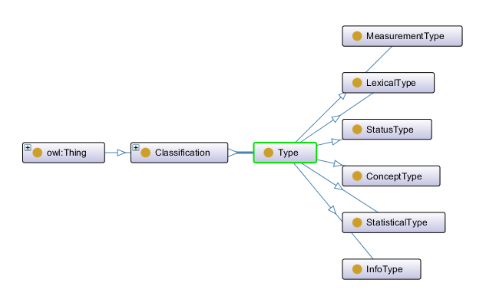

Figure 1 – The hierarchy of classes in the ESTAT ontology.

#### NLP4StatRef Ontology ¤ Object Properties

| Property | URI | Domain | Range | Usage |
| --- | --- | --- | --- | --- |
| hasClassification | estat:hasClassification | estat:Content | estat:Classification | A property that shows if an article from the Editorial Content has any Classification |
| hasCategory | estat:hasCategory | estat:Content | estat:Category | A property that relates an article from the Editorial Content with its Categories |
| hasCategoryOfGlossaryArticle | estat:hasCategoryOfGlossaryArticle | estat:GlossaryArticles | estat: GlossaryArticleCategory | A property that relates an article from the glossary category with its category(-ies) |
| hasCategoryOfStatisticExplainedArticle | estat:hasCategoryOfStatisticExplainedArticle | estat:StatisticsExplainedArticles | estat:StatisticsExplainedCategory | A property that relates an article from the statistics explained category with its category(-ies) |
| hasTopic | estat:hasTopic | estat:Content | estat:Topic | A property that relates an article from the Editorial Content with its Topics |
| hasType | estat:hasType | estat:Content | estat:Type | Some articles from the Editorial Content may have some information about their lexical type, status type, and others |
| hasGlossaryTerm | estat:hasGlossaryTerm | estat:Content | estat:GlossaryTerm | A property that shows if an article from the Editorial Content has any Glossary Term |
| hasCode | estat:hasCode | estat:StatisticalData | estat:Code | A property that relates a dataset to its code(-s). Basically is the labels of the Statistical Data |
| hasNamedEntity | estat:hasNamedEntity | estat:Content | estat:NamedEntity | A property that relates an article from the Editorial Content with the named entities that it contains |
| hasCODEDTerm | estat:hasCODEDTerm | estat:Content OR estat:Classification | estat:CODEDTerm | A property that relates entities from the Editorial Content with the CODED Terms |
| hasOECDTerm | estat:hasOECDTerm | estat:Content | estat:OECDTerm | A property that relates entities from the Editorial Content with the OECD Terms |
| hasTheme | estat:hasTheme | estat:Content | estat:Theme | A property that relates the Editorial Content entities with their Theme(-s) |
| hasReference | estat:hasReference | estat:Content OR estat:CODEDTerm OR estat:OECDTerm | estat:Reference | A property that relates articles or terms with references material (e.g. databases, articles, legislation, etc.) |
| mapsToTheme | estat:MapsTheme | estat:OECDTheme | estat:EurostatTheme | A property that relates a OECD Entity with the EuroStat Theme(-s) |
| hasParagraph | estat:hasParagraph | estat:StatisticsExplainedArticles | estat:Paragraph | A property that relates the Statistics Explained Articles with its paragraphs |
| hasOECDTheme | estat:hasOECDTheme | estat:OECDTerm | estat:OECDTheme | A property that relates the OECD themes with the OECD terms |
| internalURI | estat:internalURI | estat:Reference | estat:Content | A property that relates referenced resources with an entity from the content class |

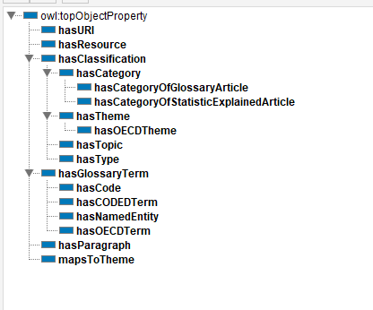

Figure 2 – The hierarchy of the object type relations in the ESTAT ontology.

#### NLP4StatRef Ontology ¤ DataType properties

The classes created to describe the relevant data to meet the use cases are the following:

| Property | URI | Domain | Range | Usage |
| --- | --- | --- | --- | --- |
| content | estat:content | estat:Article | xsd:string | This property relates the articles from the editorial content with their Content (i.e., their Abstract or a small Description) |
| context | estat:context | estat:Article OR estat:OECDTerm | xsd:string | A property that relates the Articles from the Editorial Content with their context (a small description of the context that the article is applicable to) |
| dataSource | estat:dataSource | estat:Article | xsd:string | A property that connects the articles from the Editorial Content with their Data Source(-s) (which are strings) |
| dateCreated | estat:dateCreated | estat:Content OR estat:GlossaryTerm | xsd:dateTimeStamp | A property that relates a glossary entity with its creation date |
| dateUpdated | estat:dateUpdated | estat:Content OR estat:GlossaryTerm | xsd:dateTimeStamp | A property that relates a glossary entity with the date that was updated |
| definition | estat:definition | estat:CODEDTerm OR estat:OECDTerm | xsd:string | A property that relates a glossary entity with its definition |
| fileDescription | estat:fileDescription | estat:StatisticalData | xsd:string | A property that relates a dataset with its file description |
| Id | estat:id | estat:Content OR estat:GlossaryTerm OR  estat:StatisticalData | xsd:integer | A property that indicates the ID of the glossary or the content entity |
| keyword | estat:keyword | estat:Topic | xsd:string | A property that relates the an instance from the class Topic with its keyword(-s) |
| term | estat:term | estat:GlossaryTerm | xsd:string | A property that indicates the label of the dataset and the label of the Vocabulary entity |
| level | estat:level | estat:StatisticalData | xsd:string | A property that indicates the depth that the dataset is in the Statistical Data tree |
| paragraph | estat:paragraph | estat:Paragraph | xsd:string | A property that relates a paragraph from the paragraph class with its context |
| remark | estat:remark | estat:CODEDTerm | xsd:string | A property that relates a glossary entity with its remark |
| sourcePublication | estat:sourcePublication | estat:OECDTerm | xsd:string | A property that relates the OECD enities with their source Publication |
| title | estat:title | estat:Content OR estat:GlossaryTerm | xsd:string | This property relates the articles from the editorial content with their Title |
| externalURL | estat:externalURL | estat:Reference | xsd:anyURI | A property that contains the URL(s) of a referenced resource |
| linkID | estat:linkID | estat:Reference | xsd:integer | A property that indicates the ID of the link. The ID is given by EuroStat |

Εικόνα που περιέχει πίνακας

Περιγραφή που δημιουργήθηκε αυτόματα

Figure 3 – The hierarchy of the data type relations in the new ESTAT ontology.

Moreover, the NLP4StatRef-Ontology-datasets-v2.1.owl file contains the hierarchy of the Eurostat datasets that exist in the Content Database